Design Document
Project: ARTNEST – Personal Museum Memory & Wishlist
Course: IN-SDE-EN-CMK
Table of Contents
Design Document 1
1. Introduction 2
2. User Activity Flow Chart 2
3. Design Wireframe 3
4. Final Site Design Wireframe 3
5. Mobile-Responsive Design 4
6. Design Statement 4
7. Proof of Concept 5
8. Design Choices 5
9. Design Rationale (Linking Research to Design) 6
10. Class Diagram 6
11. Entity Relationship Diagram 7
12. Architecture Diagram 7

Introduction
ARTNEST is a web application designed to help museum and art gallery visitors track and organize artworks they want to see or remember. Many museum visitors encounter large collections of artworks during visits or discover artworks online but later forget their names, locations, or museums.
The goal of the ARTNEST platform is to provide a simple digital space where users can search for artworks, view artwork information, and save artworks to a personal collection. This allows users to organize artworks they want to see in the future or remember artworks they have already discovered.
The system focuses on usability and simplicity, ensuring that users can easily navigate the platform and manage their personal artwork collections. The design combines a clean interface with a structured backend architecture that supports dynamic content and user-specific data.

User Activity Flow Chart
The user activity flow chart illustrates the main interaction flow of the ARTNEST system. It begins when a user opens the website and either logs in or registers if they are not authenticated. After successful authentication, the user can search for artworks, view artwork details, and save artworks to a personal collection. Saved artworks can later be accessed through the user’s collection page. The diagram helps visualize the main user journey and supports the design of a clear navigation structure.

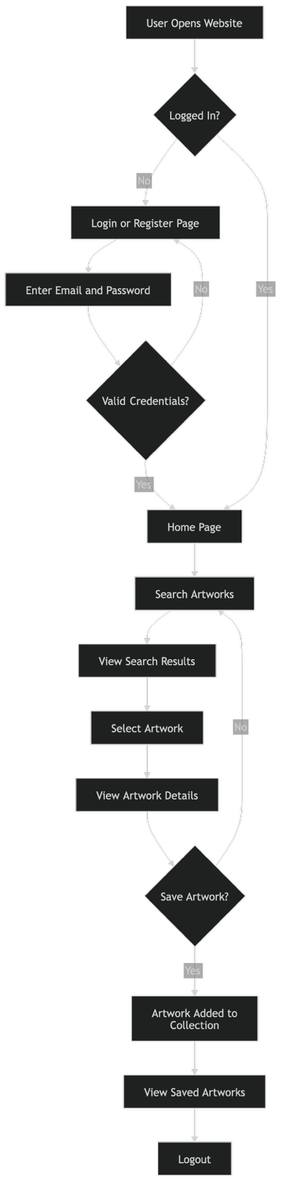

Design Wireframe
During the early design stage, wireframes were created to explore possible layouts and navigation structures for the ARTNEST web application. These wireframes helped visualize how users would move through the system and interact with core features.
The initial wireframes focused on the main pages of the platform, including:
- Landing page
- Artwork search page
- Artwork detail page
- Saved artworks collection page
- User account page
At this stage the goal was to define layout structure and user flow rather than finalize visual design. The wireframes helped determine where important interface elements such as navigation, search functionality, and artwork cards should be placed.
As development progressed, several elements were simplified to keep the system focused on the core functionality of discovering and saving artworks.

Final Site Design Wireframe
The final design of the ARTNEST interface builds upon the ideas explored during the wireframing phase. The interface includes both public and authenticated sections of the application.
The landing page introduces the platform and allows users to register or log in. Once authenticated, users gain access to additional pages such as their personal collection and artwork search features.
The navigation bar adapts based on whether the user is logged in. Logged-out users see options such as Home, Login, and Register, while logged-in users gain access to additional features including Search Artworks and Saved Artworks.
Artwork results are displayed using a card-based layout, allowing users to quickly scan artwork information and interact with the interface in a clear and structured way.

Mobile-Responsive Design
The ARTNEST interface was designed with responsiveness in mind to ensure usability across different devices and screen sizes.
The layout adapts automatically when viewed on smaller screens such as smartphones or tablets. Multi-column layouts collapse into single-column views to improve readability and prevent horizontal scrolling.
Navigation also adapts for mobile devices by using a collapsible menu that allows users to access all main pages without cluttering the interface.
Artwork cards, buttons, and interactive elements are spaced appropriately for touch interaction, ensuring that users can easily navigate the platform on both desktop and mobile devices.

Design Statement

Color Palette
The interface uses a soft and neutral background combined with warm accent colors to create a calm and approachable visual style. Light backgrounds help reduce visual fatigue while accent colors highlight important actions such as saving artworks or navigating between pages.

Typography
A modern sans-serif typeface is used throughout the interface to ensure readability across different devices. Typography follows a clear hierarchy with strong headings for page titles and smaller text for supporting information.

Layout
The layout follows a clean card-based design. Each artwork is presented as a card containing key information such as title, artist, and museum. This approach makes it easy for users to browse and organize artworks visually.

Visual Feedback
Visual feedback is provided through interface elements such as confirmation messages, hover effects, and highlighted buttons. These elements help users understand when an action such as saving an artwork has been successfully completed.

Proof of Concept
A functional prototype of the ARTNEST web application was developed to demonstrate the core features of the system.
The prototype includes the following functionality:
- User registration and login
- Searching for artworks
- Viewing artwork details
- Saving artworks to a personal collection
- Viewing saved artworks
The application was implemented using ASP.NET Razor Pages combined with C# backend logic. Razor syntax allows dynamic content to be rendered on web pages while maintaining a structured architecture.
The prototype demonstrates how the system retrieves artwork information and links saved artworks to the user’s account.
Testing was performed through manual walkthroughs of the main user flows, including account creation, searching for artworks, saving artworks, and viewing saved collections.

Design Choices

Layout and Navigation
- A card-based layout was selected to present artworks in a visually organized way.
- Navigation is placed at the top of the interface to provide quick access to the main system pages.
- Consistent page structure helps users quickly understand how the interface works.

Color and Typography
- Neutral backgrounds reduce visual distraction and keep the interface focused on the artwork content.
- Accent colors highlight interactive elements such as buttons and saved items.
- Typography hierarchy improves readability and information scanning.

Design Decisions
- The interface prioritizes core features such as artwork discovery and collection management.
- Secondary features were intentionally excluded to keep the system simple and focused.
- The design emphasizes clarity and usability rather than visual complexity.

Design Rationale (Linking Research to Design)
The design of the ARTNEST platform is based on findings from the research phase. The research showed that museum visitors often struggle to remember artworks they discover during visits or online. Because of this, the system focuses on allowing users to save and organize artworks in a personal collection.
Analysis of existing platforms such as Google Arts & Culture, Artsy, and Smartify showed that many systems focus on discovering artworks but provide limited tools for personal tracking. This influenced the decision to prioritize saving artworks and viewing personal collections as core features of the platform.
Usability research also influenced the interface design. A card-based layout was chosen because it allows artworks to be displayed in a clear and easy-to-scan format, improving navigation and usability.

UML Diagram
The class diagram represents the main data structure of the ARTNEST system and shows how the core entities are related. The diagram includes the classes User, Artwork, and SavedArtwork. Primary keys and foreign keys are included to clarify how the entities are connected. The SavedArtwork class links users and artworks and stores the date on which an artwork was saved. This structure supports personal artwork collections while keeping artwork information centrally organized.
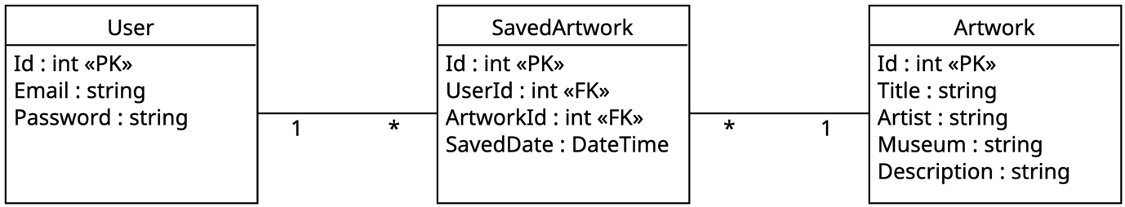

Entity Relationship Diagram
The Entity Relationship Diagram (ERD) represents how data is stored within the system database.
The diagram defines tables for users, artworks, and saved artworks, as well as the relationships between them. The SavedArtwork table contains foreign keys that reference both the user and the artwork, ensuring that saved artworks are linked correctly to user accounts.
This database structure supports efficient querying and ensures that user collections are stored in a consistent and organized way.
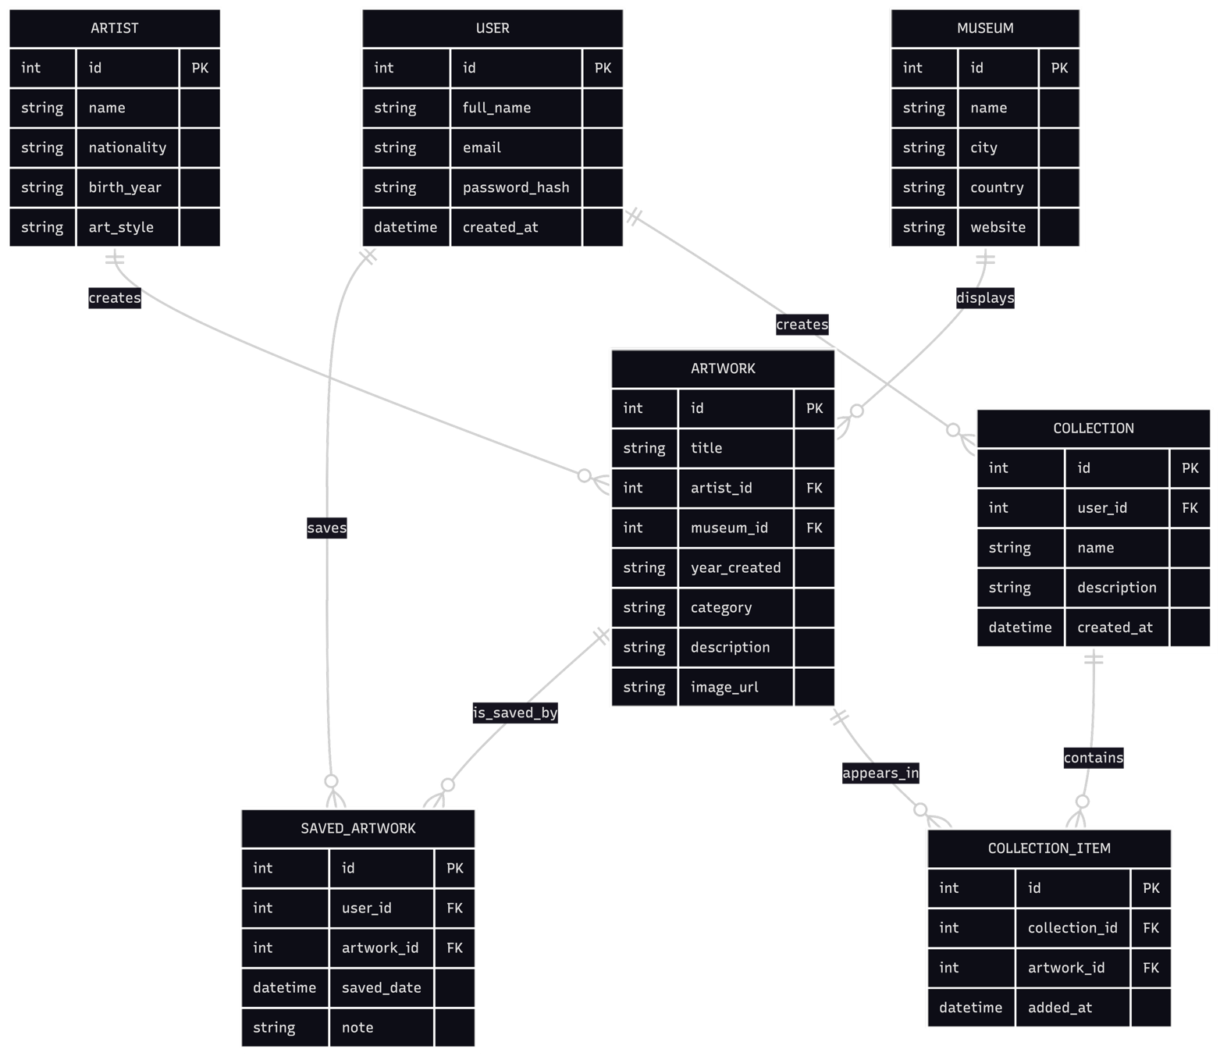

Architecture Diagram
The architecture diagram illustrates the technical structure of the ARTNEST system and how different layers interact. The user accesses the application through a web browser, which loads the frontend interface built with ASP.NET Razor Pages, HTML, and CSS. The frontend communicates with the backend application layer, where C# services handle business logic such as authentication, artwork search, and managing saved artworks. The backend then interacts with the database layer, where data related to users, artworks, and saved collections is stored. This layer
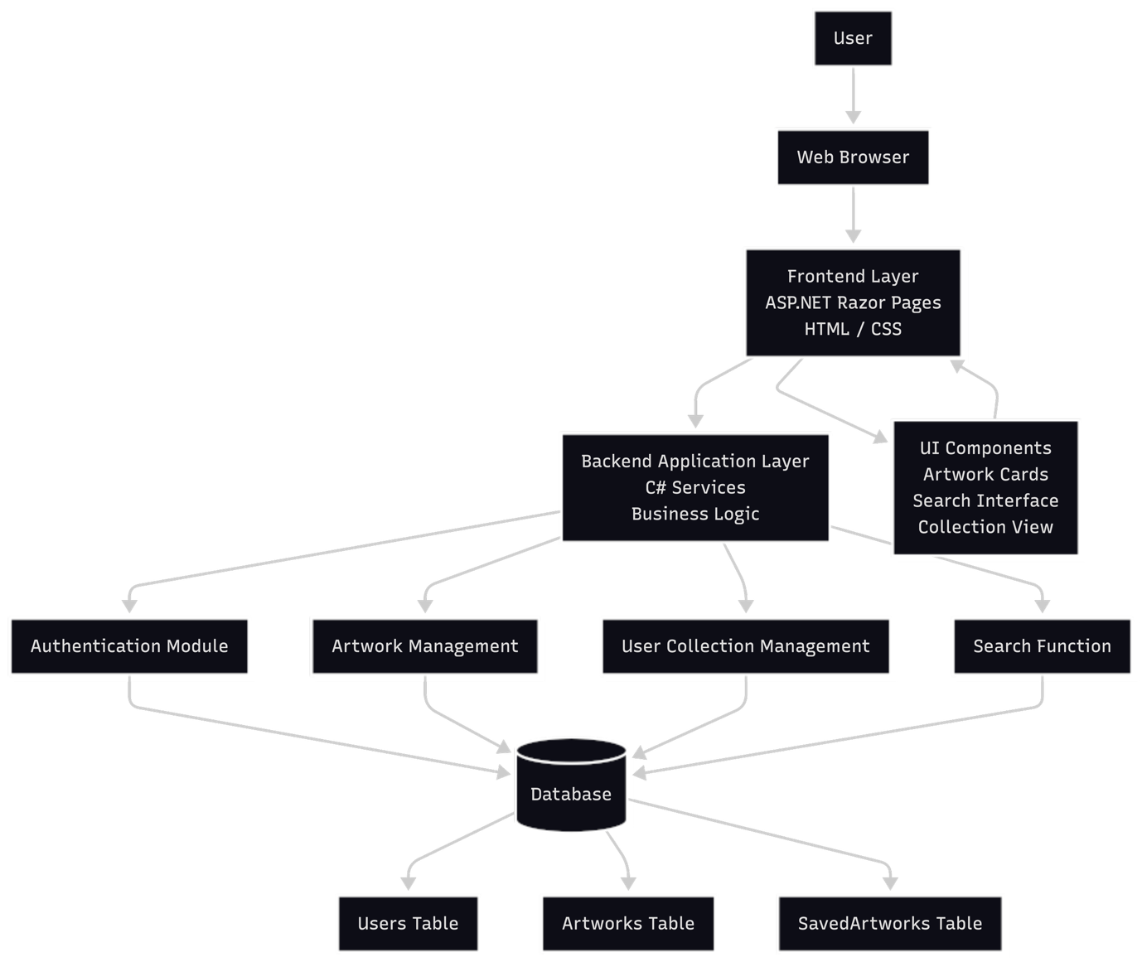
ed architecture separates the user interface, application logic, and data storage, making the system easier to maintain and extend.

